BCS Online for accordors

Inhoudsopgave
1 General 4
2 Manager tab 5
2.1 Approval of personal and address details 5
2.2 Procedure 5
3 Approve declarations 6
3.1 Reporting 7
4 Approve time registration requests 8
4.1 Reporting 8
4.2 Completed week reports 8
4.3 Missing week reports 9
5 Approve leave 11
5.1 Overview 11
5.2 Balances 12
5.3 Group overview 12
5.4 Reporting 13
6 Workschedule 14
7 Additional functions tab Employee 15
7.1 Helping an employee 15
8 BCS Online on telephone or tablet 15
8.1 BCS Online shortcut on iPhone home screen 15
8.2 BCS Online shortcut on Android phone home screen 17

General
This manual describes all the extra functionalities that are available to you, as an accordor, in BCS Online. All standard BCS Online features are described in the 'BCS Online for employees' manual. We recommend that you also read this manual carefully.
The administrator of BCS Online has given you extra functionalities so that you can check clock registrations, check and approve time registrations, absence requests and declarations. You can also consult group overviews of all employees assigned to you.
These additional functions are housed in the 'Manager' tab.
The tiles that belong to the 'Manager' tab can be recognized by the addition 'employees':
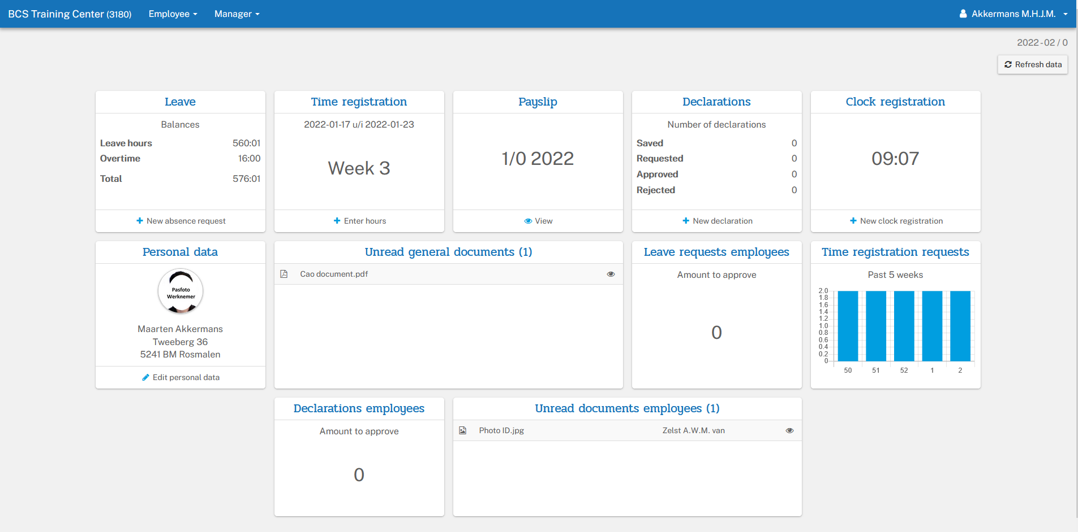

Logging in takes place in exactly the same way as described in the manual 'BCS Online for Employees'.

Manager tab
After logging in, you will see an additional 'Manager' tab on BCS Online:
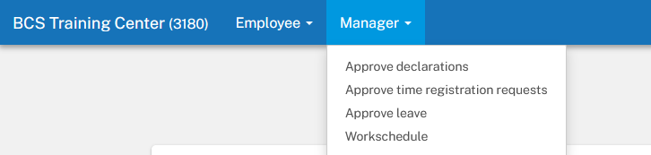
Within the 'Manager' tab, the following functions are available:
Approve declarations: This function allows you to view and approve the employee's submitted claims.
Approve time registration requests: Within this position you can view and approve the weekly reports of the employees. You can also change the hours worked here (calculated on the basis of the clock times read in).
Approve leave: This position allows you to view and approve the employee's requested absences.
Workschedule: Here you can assign a different day program to an employee, or change the two-day program.

Approval of personal and address details
This is done in Delta HRP and can only be done by users who have access to Delta HRP. So even if you're an accordor for these changes, you can't approve them in BCS Online.

Procedure
Within the 'Manager' tab you can approve the submitted declarations, weekly reports, leave requests of the employee. You can also assign work schedules here.
- Only the weekly reports, leave requests, employee declarations with the status 'Pending', 'Revocation' or 'For verification' are visible. After approval, it disappears from the overview.
- Double-clicking on a line will open the follow-up screen with all the details.
- The detail display is similar in layout to the screen with which the employee initially submitted the weekly reports, leave requests, declarations. The big difference is that the screen is now displayed in 'read only' mode. In addition, the number of buttons to use is more limited and the Approve, Disapprove and Cancel buttons are visible.
- Before approving or rejecting, the accordor has the opportunity to post a comment. This becomes visible to the employee in question.

Approve declarations
The tile displays the number of declarations to be approved.
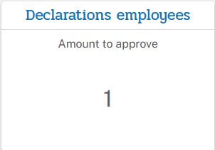
If you click on the tile or in the 'Manager' menu on 'Approve declarations' you will see a list of all declarations to be approved. Each declaration can be opened separately by clicking on it.
Now the declaration items become visible.
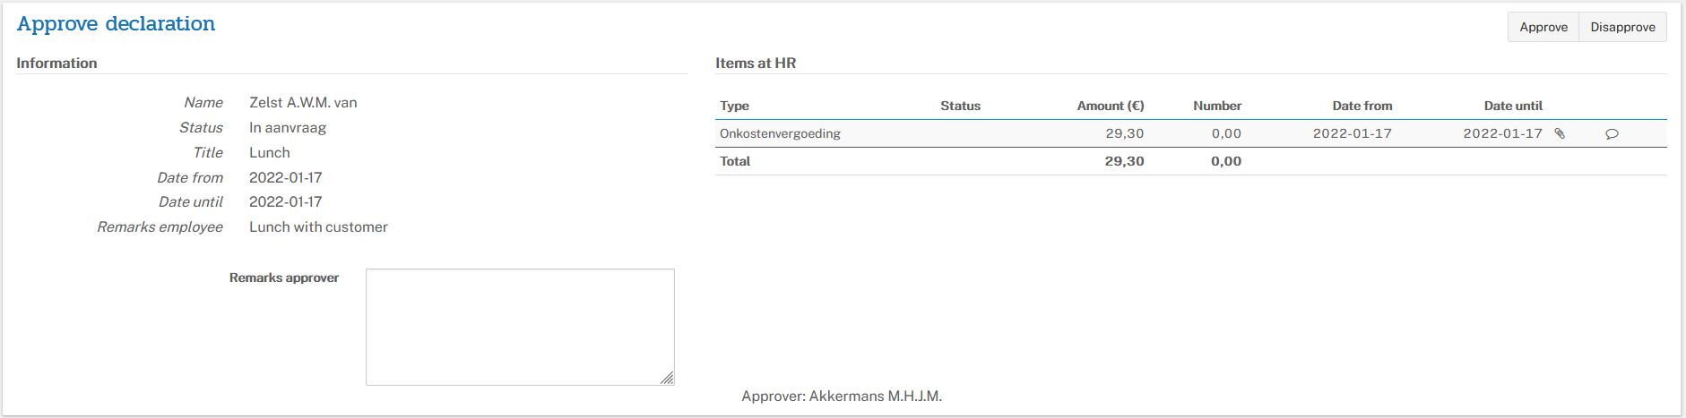
When you click on an item, the name of the added file becomes visible and the employee's comments (if they have been added).
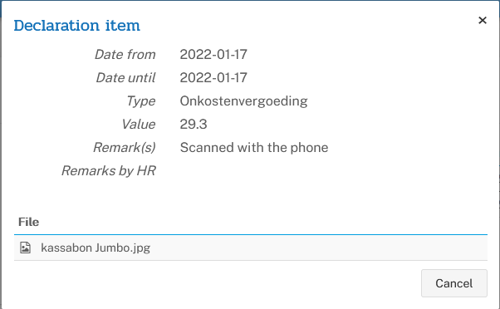
If you click on the file name, and it is an Office document, you will get the message:
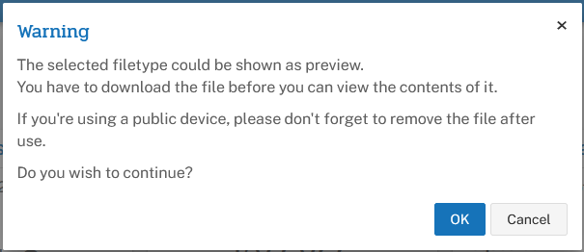
After clicking OK, the file is displayed.
Finally, click Approve or Disapprove. If you want to disapprove, it is wise to mention the reason under 'Remarks approver' before clicking on Reject.

Reporting
Click Reporting to view all submitted claims. Choose one from and until date to shorten the list. On the right you have a choice to show Disapproved declarations and the remarks present.
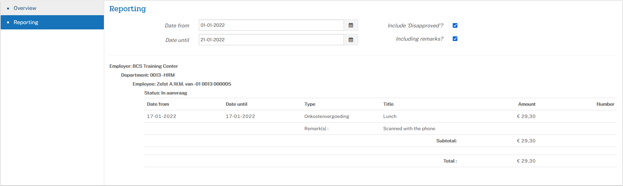

Approve time registration requests
The main task in 'Approving time registration requests' is to assess weekly reports and/or project registrations. In addition, you can consult reports and view the missing weekly reports.

Reporting
Follow the steps provided by this reporting tool.

Completed week reports
You will see a list of all the week reports that need to be reviewed by you.
In the search screen, for example, you can enter the name of the employee to see all week reports (with status 'For verification') of this employee or, for example, a week number to display all week reports of that week in question.
To the middle of the search screen, you can also choose a specific week from a particular year.
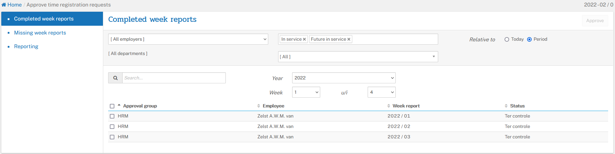
If you click on a week report, you will be taken to the detailed screen of the week reports.
You can now choose from 'Week report', 'Project registrations' or 'Show all registrations'.
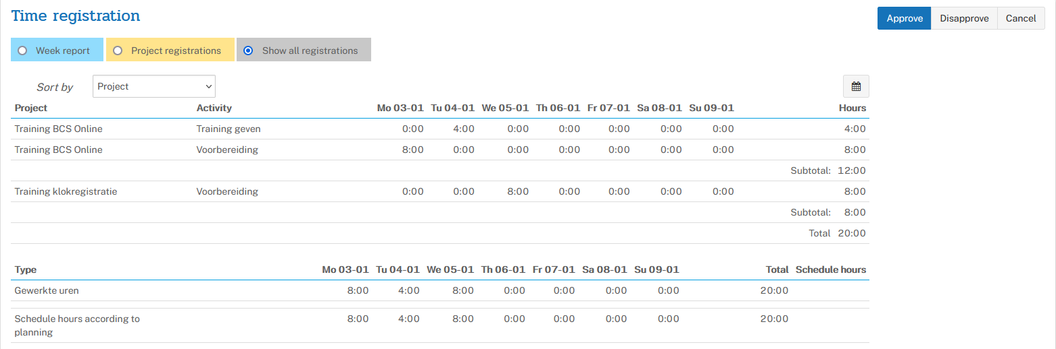
If you click on the calendar button, you can view the employee's comment.
Of course, this also applies to a project/activity registration.

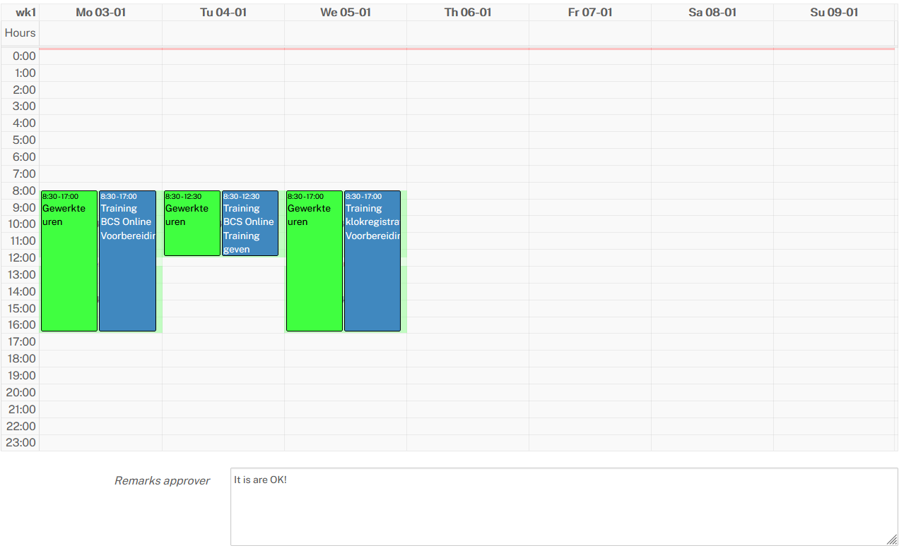
Review the registrations and finally click Approve or Disapprove. It is not possible to approve or reject a week report and project registrations separately. If the project registrations are incorrect or incomplete and you want the employee to adjust them, you must therefore reject the entire week report (= offer it to the employee for correction). If you disapprove of a week report, it is wise to state the reason under 'Remarks approver'.

Missing week reports
When you open the missing week reports, you'll have the same search options as under "Completed week reports."
The first column is a checkbox. If you place a check mark here, the option 'Compose message' will become available on the right side. If you put a check mark in front of Approval Group, everything will be selected.
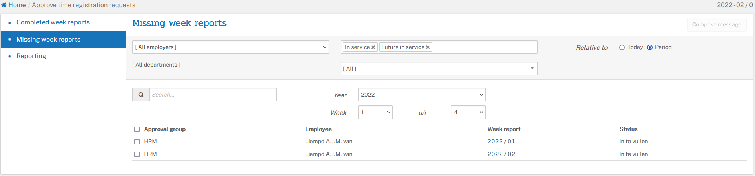

You can now send a message as a reminder:
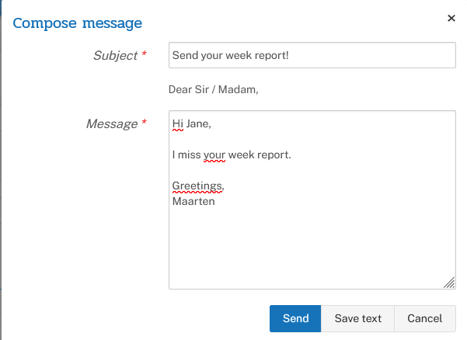
By saving the text you can use it again the next time. The employee receives an e-mail message with the text as entered under 'Compose message' and a list of the checked missing week reports.

Approve leave
The main task under Approve Leave is to assess the submitted leave requests. On the left you have an option to see all requests via overview, the balances, the group overview and the reports.

Overview
You'll see a list of all leave requests to review.
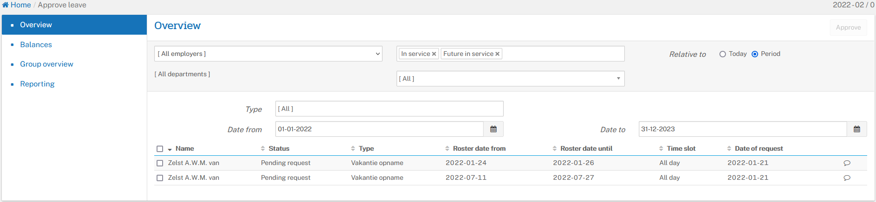
By clicking on a leave request, you will enter the detail screen. In this example you will see the 'list view'. You start this by clicking on the lines button on the right side of the screen. In the list view, right-click the calendar button to start calendar view.
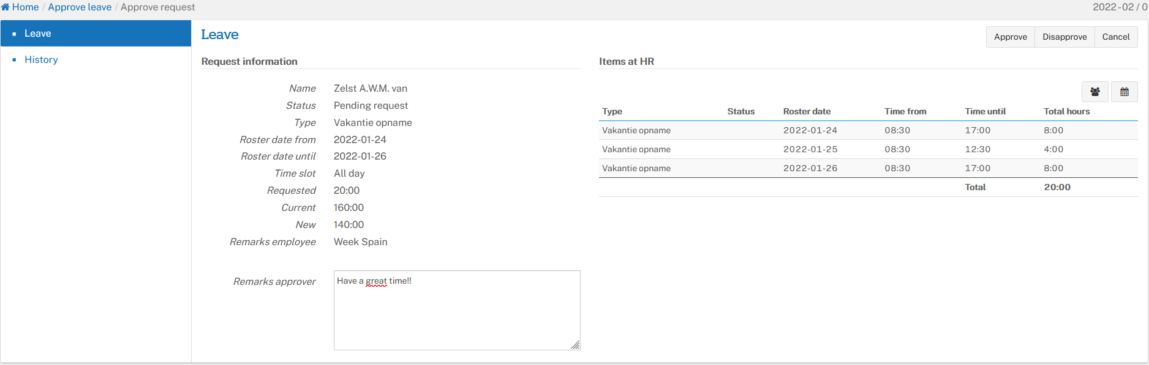
From 'calendar view'
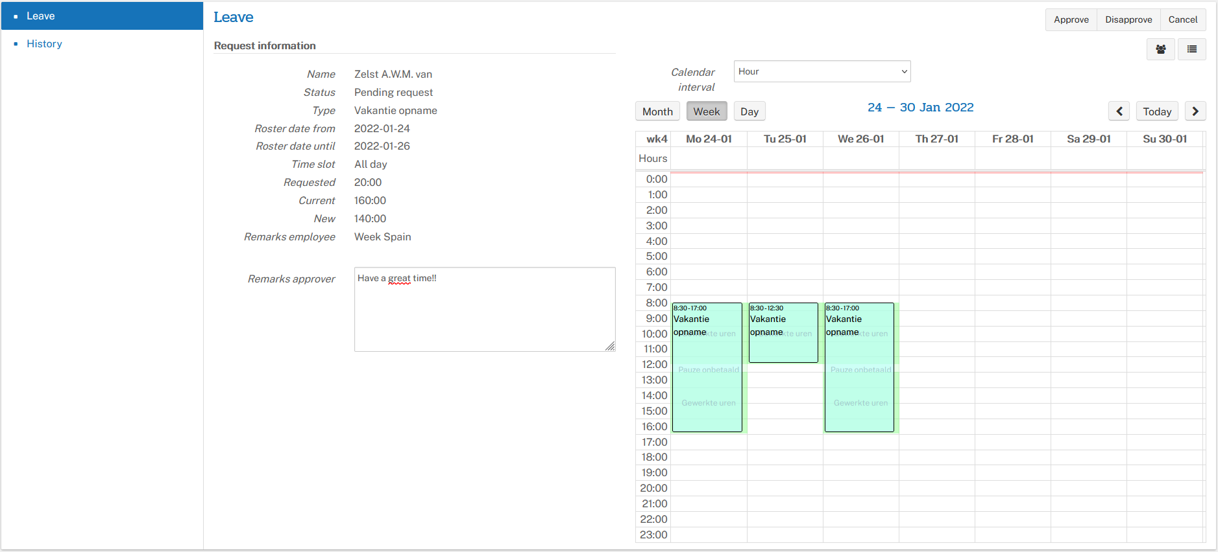
Here you can use the 'Approve' and 'Disapprove' buttons to further process the request. You can use the Remarks approver field to return a comment to the employee. Especially in case of disapproval, it is advisable to enter the reason for rejection here.

Balances
Here you will find the credits of all employees assigned to you.
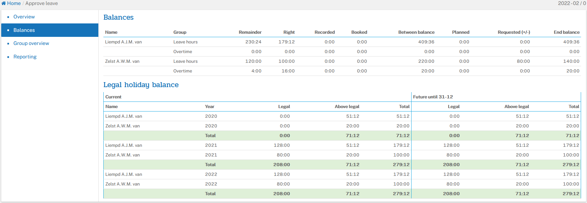

Group overview
Here you will find an overview of all employees assigned to you of their presence. The top line shows the employees schedule. The possible second rule their absence. By moving the mouse over the text, the reason for the absence is shown.
If there is a '*' in the absence, the leave request has not yet been approved.
If it is permitted by your employer, you can switch to another department/employer in the approval group to get an overall picture.
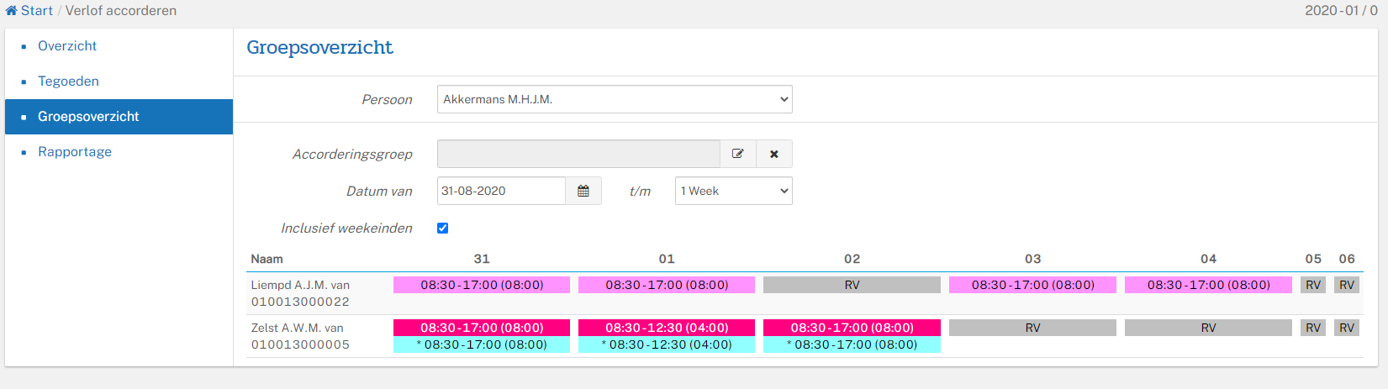

Reporting
Here you can, of one or all employees, make reports of leave and / or credits.

Workschedule
You can assign a different day program to an employee. You do this when an employee comes to work at different times or needs a day program that includes overtime allowances. These are incidental changes.
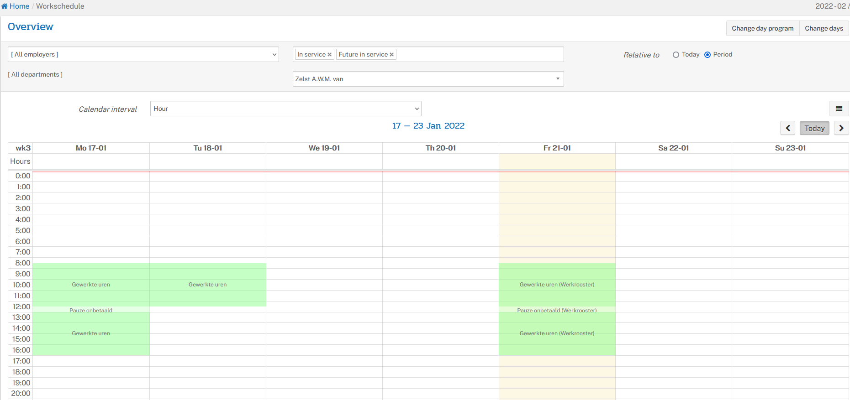
You can choose between 'Change day program' or 'Change days'.
When applying work schedule, the 'horizon widening' will be applied automatically. Also, a red notification as may be displayed.
For some notifications, such as the above, it is not possible to confirm the Work Schedule. This is possible with orange notifications.
The 'horizon' is shown as a pink line. The horizon indicates the end of the day. With a day program from 08:30 – 17:00 hours this will usually be 00:00 hours at night. When a new day program with a night transition is laid down on the same day, the end time of the previous day program will have to be shortened.

Additional functions tab Employee

Helping an employee
Within the functions Clock registration, Time registration, Leave, Declarations and My documents you will find an extra field to select the name of the Employee. Only the persons in your team are shown.
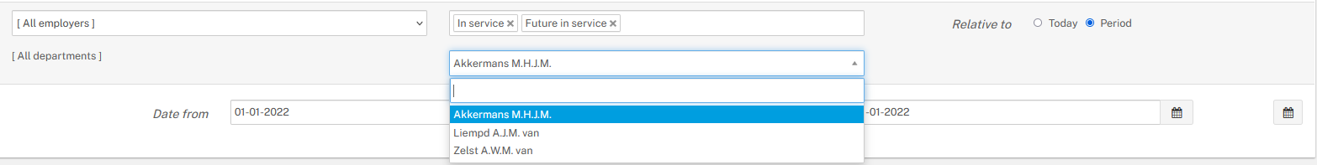
By selecting one of the employees assigned to you, you can consult, view and/or submit changes. This is practical if this employee cannot do this himself.
In the clock registration feature, you can view historical clock times of the employees assigned to you. It is also possible to enter or change clock times for the employees. Changing clock times at this location is only possible before they have been processed. Processing is done in the salary and personnel information package Delta HRP, which can be processed daily or weekly, for example.

BCS Online on telephone or tablet
BCS Online, the employee portal, can be used on any device. So on your PC/laptop, your tablet and on your phone. BCS online works well in the Browser on all devices. Via the browser you use the URL: bcsonline.nl
All BCS Online functions are available in this way.
If you wish, you can pin this URL to your phone's home screen.

BCS Online shortcut on iPhone home screen
To get the icon on your home screen, follow these steps:
- Open the Safari program
- Type the URL: bcsonline.nl and press Go (See image 1)
- Select the option at the bottom center of the screen
- Slide the screen up and choose the option: Put on home screen (see image 2)
- Choose the name you want to add to the icon and click Add (see image 3)
- Your icon is on your home screen and you can now move it if necessary (see images 4
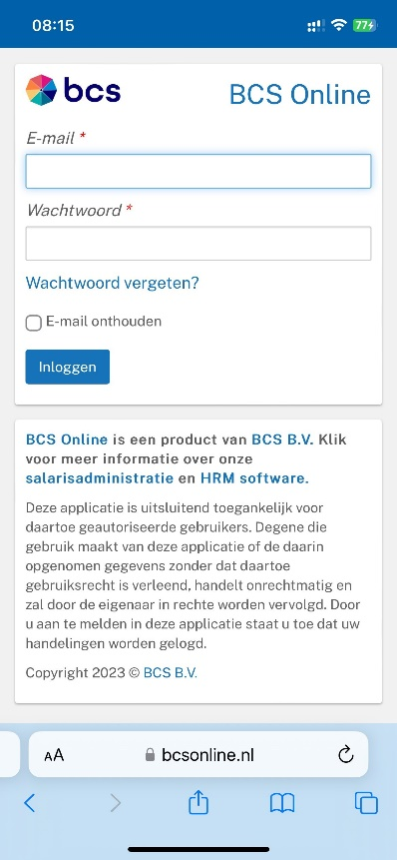 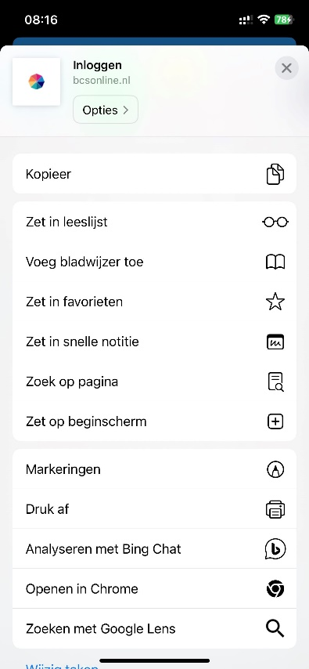
Image 1 Login screen BCS Online Image 2 Option: Set on Home screen
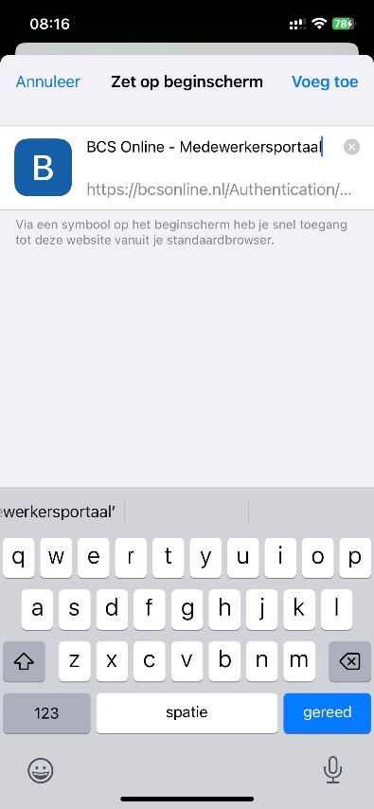 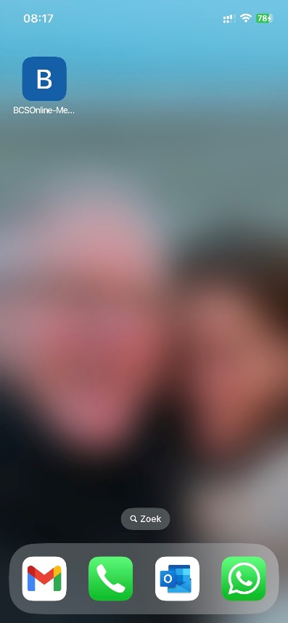
Image 3 Enter name at icon Image 4 BCS online icon on Home screen

BCS Online shortcut on Android phone home screen
To get the icon on your home screen, follow these steps:
Please note: there may be small differences in the Android phones and therefore also in the steps!
- Open the Chrome program
- Type the URL: bcsonline.nl (see image 5)
- Press the button with the three dots (top right)
- Press Add to Home Screen (see Figure 6)
- Choose the name you want to place next to the icon (see image 7)
- Press Add (possibly again if prompted)
- Your icon is on your home screen and you can now move it if necessary (see image 8
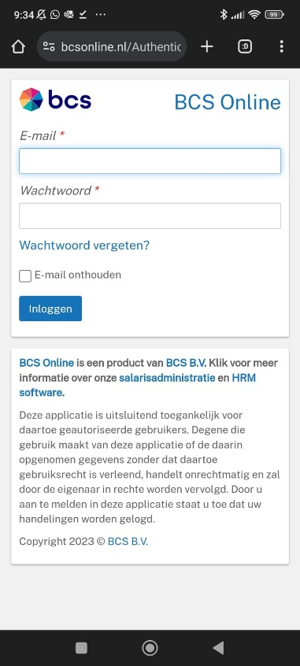 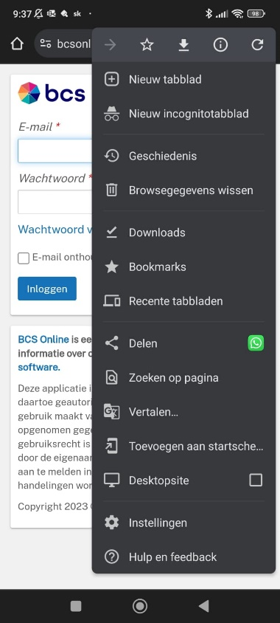
Image 5 Login screen BCS Online Image 6 Option: Set on Home screen
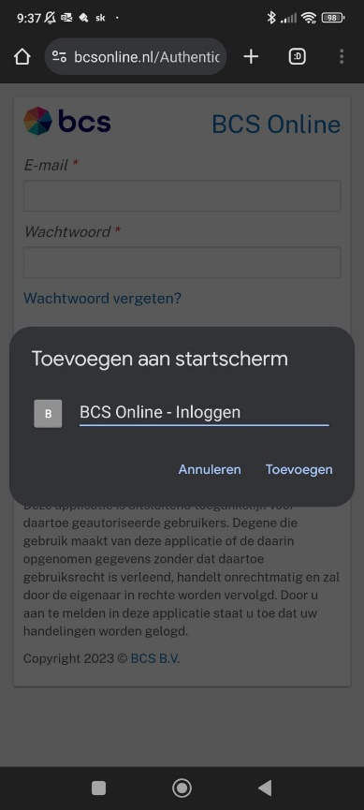 
Image 7 Enter name at icon Image 8 BCS Online icon on Home screen

BCS HR Software will continue to expand BCS Online. Do you have questions about the possibilities of BCS Online or comments about this manual? Please contact your BCS Online administrator. He/she will further discuss this with BCS HR Software.

